MEAN project ‘s server.js file-------node-todo project

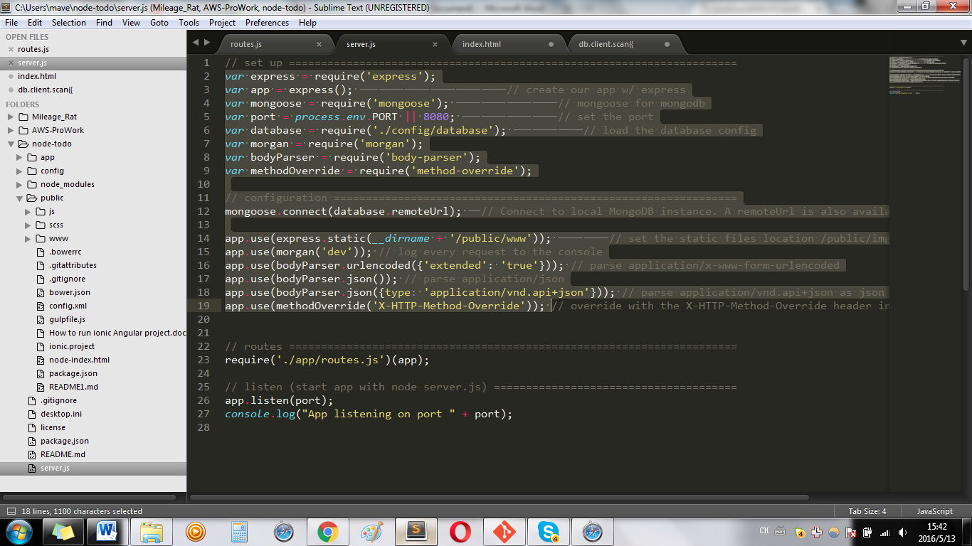

Server.js

Type $node server.js can run the project—node-todo

var express = require('express');

var app = express(); // create our app w/ express

var mongoose = require('mongoose'); // mongoose for mongodb

var port = process.env.PORT || 8080; // set the port

var database = require('./config/database'); // load the database config

var morgan = require('morgan');

var bodyParser = require('body-parser');

var methodOverride = require('method-override');

// configuration ===============================================================

mongoose.connect(database.remoteUrl); // Connect to local MongoDB instance. A remoteUrl is also available (modulus.io)

**app.use(express.static(__dirname + '/public/www'));**

**// the line above is to set the path of index.html, which server.js would search to run as the first page**

app.use(morgan('dev')); // log every request to the console

app.use(bodyParser.urlencoded({'extended': 'true'})); // parse application/x-www-form-urlencoded

app.use(bodyParser.json()); // parse application/json

app.use(bodyParser.json({type: 'application/vnd.api+json'})); // parse application/vnd.api+json as json

app.use(methodOverride('X-HTTP-Method-Override'));